Assignment (3.1)
- import pandas.


- Import Iris dataset.
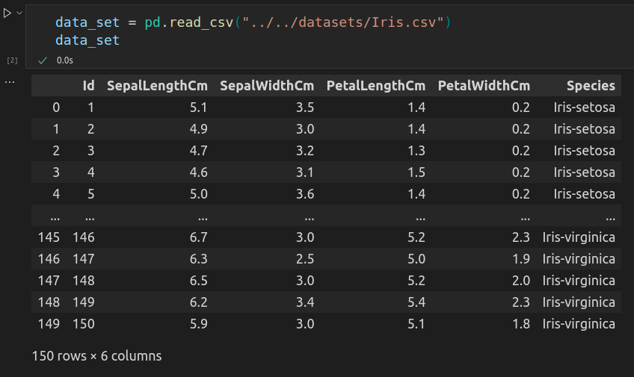
- Then we find uniqueness in Species.
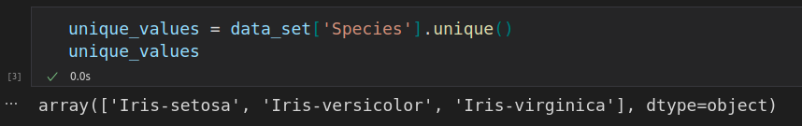

- Then find length.
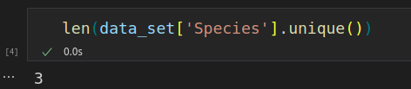

- Then we map unique data to numeric label.
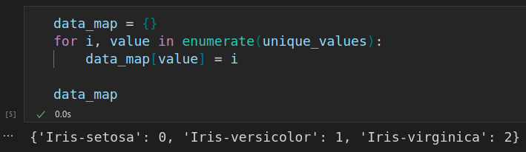
- Then we create a list in which we add all label according to Species.
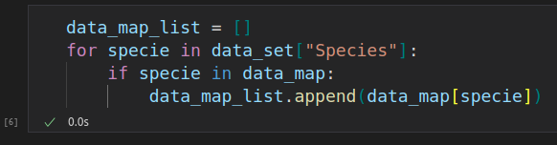

- Now, we add a column in our dataset and add data_map_list in it.
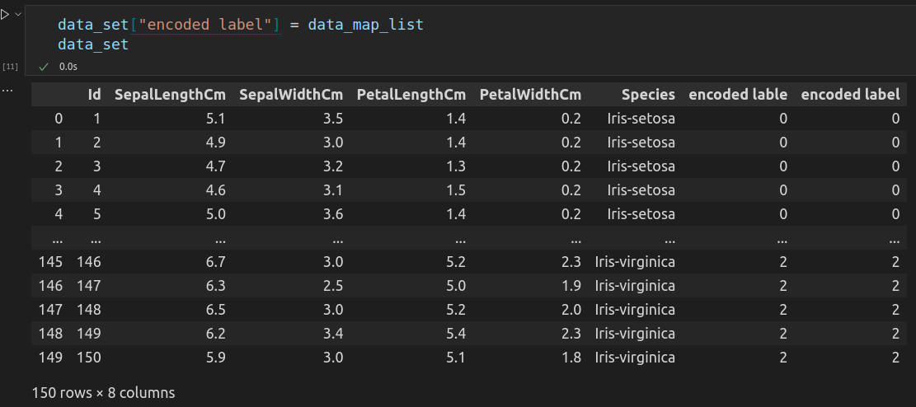
- To verify our label data we check some rows.
